PERSONAL PROFILE

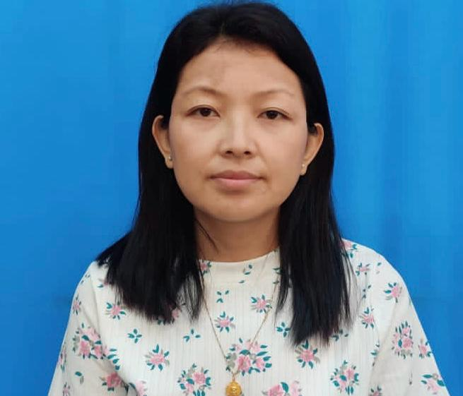
Recent Photograph

Name: - Mrs. ARPANA KALDEN

Designation: - ASSISTANT PROFESSOR IN HISTORY (WBES, Gr ‘A’)

Date of Birth: - 17/07/1988

Educational Qualification: - M.A., B.Ed.
Sl No. | Degree obtain  (Abbreviation of the degree) | College/ university from which the degree was obtained | Year of Passing
1. | B.A. HISTORY (HONS) | LORETO COLLEGE | 2008
2. | M.A. ( HISTORY) | UNIVERSITY OF NORTH BENGAL | 2010
3. | B.ED | UNIVERSITY OF NORTH BENGAL | 2012

Permanent Address: - SINJI, P.O. SINJI, KALIMPONG, WEST BENGAL, 734301

Contact Number:- 9641319330

E-mail:- arpana.kalden17@gmail.com

Date of joining (Service):- 08.08.2014

Specialization: - MODERN INDIAN HISTORY

Area of Interest: - SOCIO-CULTURAL HISTORY

Faculty Development Programme:-
Sl No. | Year | Name of Programme Participated (OP/ RC/FDP/Summer School/FEP/Others) | Organized By
1. | 2017 | 30th ORIENTATION PROGRAMME | HRDC,UNIVERSITY OF NORTH BENGAL
2. | 2020 | REFRESHER COURSE IN SOCIAL SCIENCE | HRDC,UNIVERSITY OF HYDERBAD
3. | 2023 | SEVEN DAYS WORKSHOP  (IS ARCHAEOLOGY DYING?  The Imperativeness of Archaeological Techniques in History and other Social Sciences | DEPARTMENT OF HISTORY , UNIVERSITY OF NORTH BENGAL in collaboration with AKMH MUSEUM & IQAC,UNIVERSITY OF NORTH BENGAL

Research Journal Publication (National and International) :-

International:-
Sl No. | Year of Publication | TITLE | Journal Name | ISSN/ ISBN | Published By
1. | 2023 | Educational Institutions In Colonial Darjeeling (1856-1947) | International Journal of Integrated Research and Development | ISSN. 2278-8670 | SOCIETY FOR JOURNAL OF INTEGRATED RESEARCH AND DEVELOPMENT OF INDIA
2. | 2024 | Marital Rituals and Customs of the Tamangs | International Journal of Integrated Research and Development | ISSN. 2278-8670 | SOCIETY FOR JOURNAL OF INTEGRATED RESEARCH AND DEVELOPMENT OF INDIA

Paper Presentation: Conferences/Seminars /Symposia /Workshops:-
Sl no. | Year | Title | Organized by | International  /National  / State Level
1. | 2016 | Present Scenario and Future prospects of Eco - Tourism : A Case Study of Pabong, Kalimpong | Gorubathan Government College. | National
2. | 2016 | Tamang Selo and its role in the Socio-cultural life of Tamang Tribe | Department of History,University of North Bengal | National
3. | 2019 | Marital ritual of the Tamangs with Special reference to Kinship | Department of History, Gour Banga University | International
4. | 2019 | Role of Oroxylum indicum in the Socio- cultural life of Tamang Tribe | Department of History, University of North Bengal | International
5. | 2023 | Honouring Unsung Gorkha Freedom Fighters of the India’s Freedom Struggle with Special Reference to Dal Bahadur Giri Savitri Devi, & Putalimaya Devi Poddar | Department of History, University of North Bengal | National

